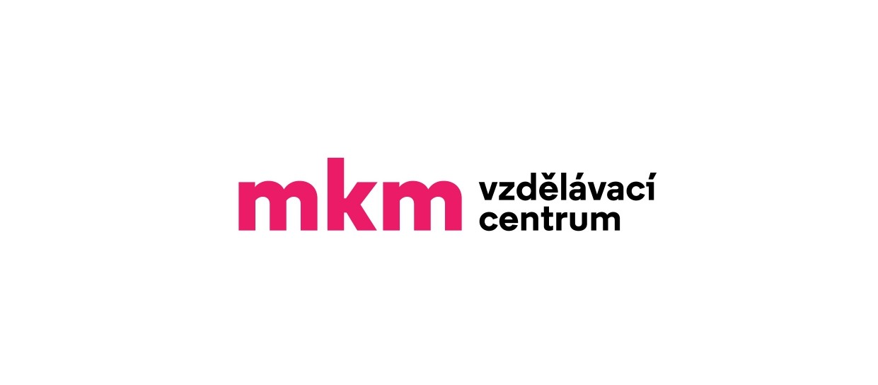*Vzdělávací centrum MKM*

**WSET® Level 1/ Level 2/ Level 3 Award in Wines - Booking Form**

Please ensure that you read the **Terms and conditions** and complete all sections on the booking form where applicable. Email the completed form to: [i](mailto:Info@mkm.cz)nfo@mkm.cz

**SECTION 1 - YOUR DETAILS**

First Name:

Surname:

Postal Address: _________________________________________________________________________________

Date of Birth:

Telephone No.:

Email Address:

**Invoice details:**

(Company) name:

Address:

IČO / (C)IN:

Have you studied WSET courses before?_______________________________________

*Your details may be used by us to keep you informed of the course on which you have registered.*

*We never pass our customer’s details to other parties.*

*We send information by email, so please ensure you have entered your email address.*

**SECTION 2 - THE COURSE**

I wish to apply for a place on the following course - please tick the chosen course:

WSET® Level 1 Award in Wines _____________

WSET® Level 2 Award in Wines _____________

WSET® Level 3 Award in Wines _____________

**NB: Study materials and examination fees are INCLUDED in course fees (according to Terms and conditions).**

Course Start Date / Place: ……………………………………...

**NB: Please read the Course Specifications before enrolling on the relevant course.**

Level 1: https://www.wsetglobal.com/media/11682/wset_l1wines_spec_en_jun2022_issue12.pdf

Level 2: https://www.wsetglobal.com/media/13167/wset_l2wines_specification_en_may2023_issue2.pdf

Level 3: https://www.wsetglobal.com/media/11731/wset_l3wines_specification_en_highres_may2022_issue2.pdf

**SECTION 3 – TERMS AND CONDITIONS**

ENG - <https://www.vzdelavaci-centrum-mkm.com/terms-and-conditions>

CZE - [https://www.vzdelavaci-centrum-mkm.com/obchodn%C3%AD-podm%C3%ADnky-terms-and-conditions](https://www.vzdelavaci-centrum-mkm.com/obchodní-podmínky-terms-and-conditions)

**SECTION 4 - MARKETING INFORMATION**

Please state how you came to hear about WSET courses and Vzdělávací centrum MKM s.r.o.:

**SECTION 5 - STUDENTS DECLARATION**

I have read and understood the Terms and conditions. I understand that all courses are subject to minimum numbers and Vzdělávací centrum MKM s.r.o. reserves the right to reschedule, cancel, close or combine courses if necessary. I understand that I am required to present authorised photographic identification at all examinations and may be refused entry to an examination if not produced.

**I agree to the processing of personal data**.

*(Souhlasím se zpracováním osobních údajů.)*

**I agree to the taking of photographs and videos during the courses.**

*(Souhlasím s pořizováním fotografií a videí během kurzů.)*

**I agree to receiving newsletters and offers related to the activities of the Vzdělávací centrum MKM s.r.o. .**

*(Souhlasím se zasíláním newsletterů a nabídek souvisejících s činností Vzdělávacího centra MKM s.r.o.)*

**I agree to the Terms and conditions.**

*(Souhlasím s obchodními podmínkami.)*

Signature______________________________________ Date________________________________________

***Vzdělávací centrum MKM s.r.o.***  *Email:* [*info@mkm.cz*](mailto:info@mkm.cz)

*Jakubská 121/1 Phone: +420702178192*

*602 00 Brno*

*CZECH REPUBLIC*